Kyle Perra

Dr. Jagodzinski

CS 460

App 2 – Design Document

**Description**

My app will operate as an account identifier – i.e. it will require the user to enter their credentials (username and password) to create an account. Once the account has been created the user will be able to manipulate their account information (password and username) and also verify this information by pressing a button that will output their credentials. It will contain two views – in the first, the user will input their information; in the second the user will be able to manipulate/verify their information.

***NOTE: This design was created in reflection of Dr. Jagodzinski’s mentioning (in class) that the database does not need to be interacted with. In later implementation (app 3), this app will send user info to a database – to which the user can later log in with these same credentials. IF NECESSARY – I will implement this into the current assignment or some other database functionality. I will check with Dr. J on this personally.***

**Layout**

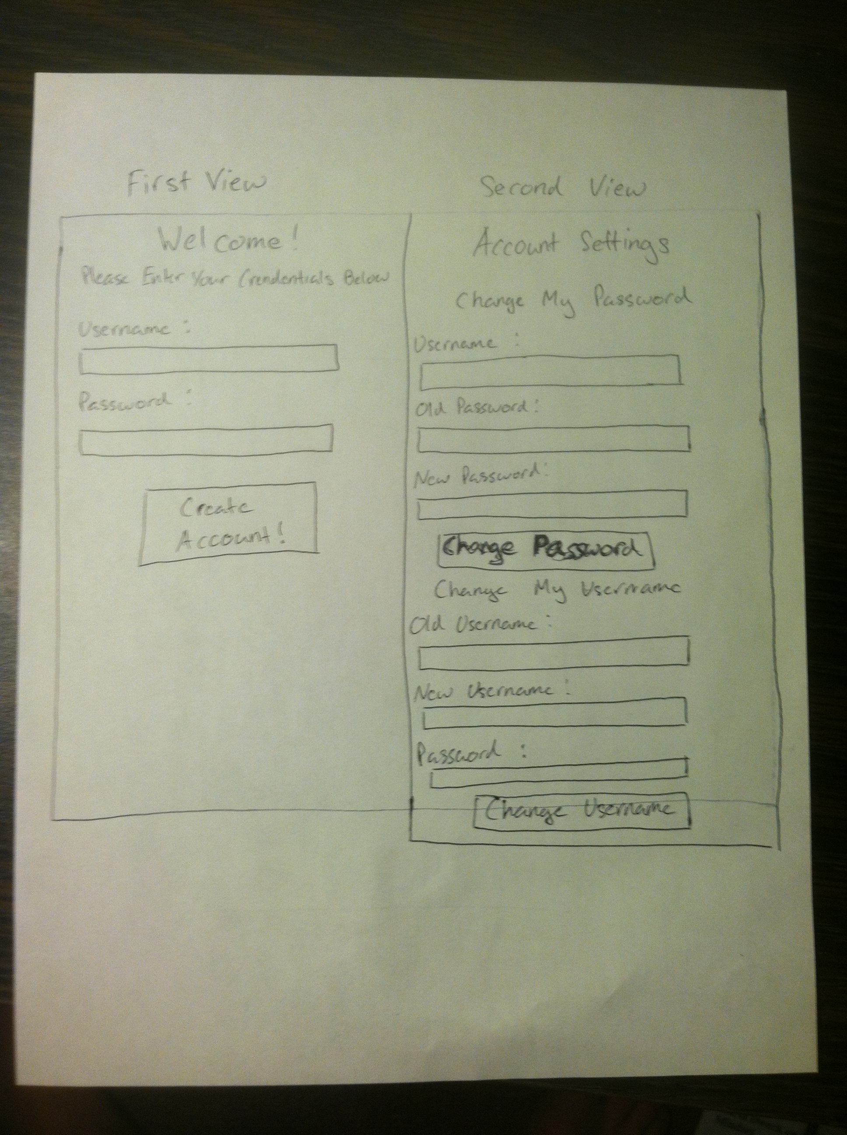

**Control Flow Diagram**

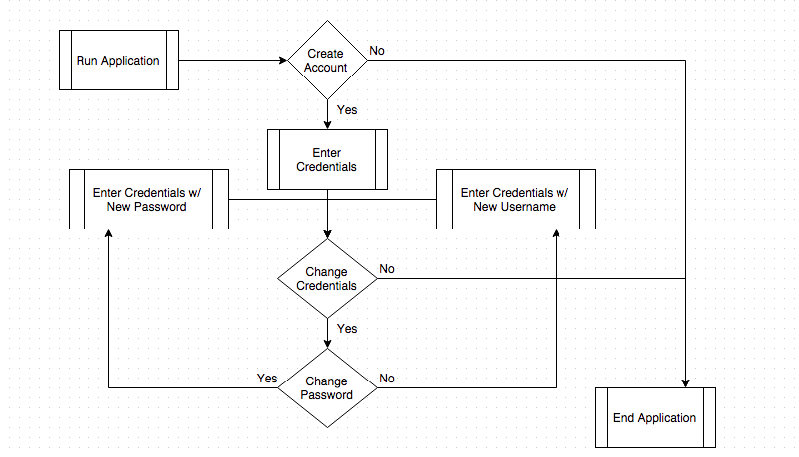

**Data Flow Diagram**

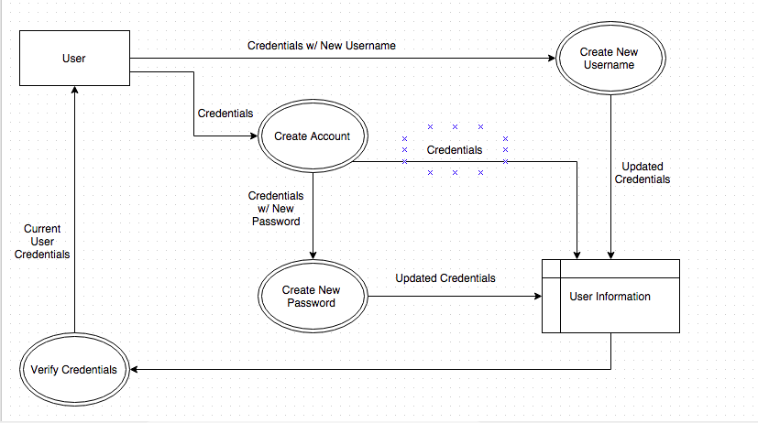

**XML**

<App2AccountIdentifier>

<UserLogInView>

<label>Welcome!</label>

<label>Please Enter Your Credentials Below</label>

<label>Username:</label>

<textfield>UserName</textfield>

<label>Password</label>

<textfield>UserPass</textfield>

<button>Create Account!</button>

</UserLogInView>

<UserAccountView>

<label>Account Settings</label>

<label>Change My Password</label>

<label>Username:</label>

<textfield>UserName</textfield>

<label>Old Password:</label>

<textfield>OldUserPass</textfield>

<label>New Password:</label>

<textfield>NewUserPass</textfield>

<button>Change Password</button>

<label>Change My Username</label>

<label>Old Username:</label>

<textfield>OldUserName</textfield>

<label>New Username:</label>

<textfield>NewUserName</textfield>

<label>Password:</label>

<textfield>UserPass</textfield>

<button>Change Username</button>

<label>Verify My Credentials</label>

<label>CredentialsOutput</label>

<button>Verify Credentials</button>

</UserAccountView>

</App2AccountIdentifier>

**Database Design**

**Table Name: Column Names: Data Type:**

AcceptedAccts UserCredName String

UserCredPass Integer